**Practical no 3**

* Working with Node.js
* Downloading current version from the official website :-

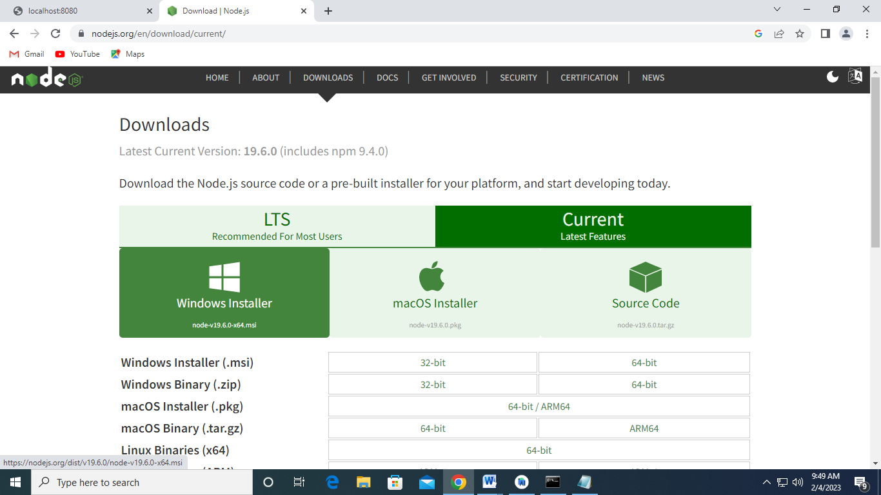

* Open .exe file :-

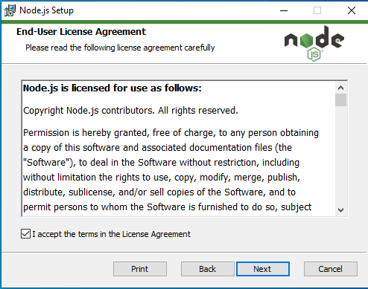

* Downloading Native Modules :-

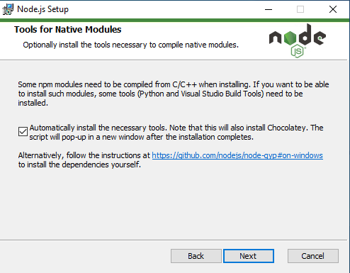

* Installing Process :-

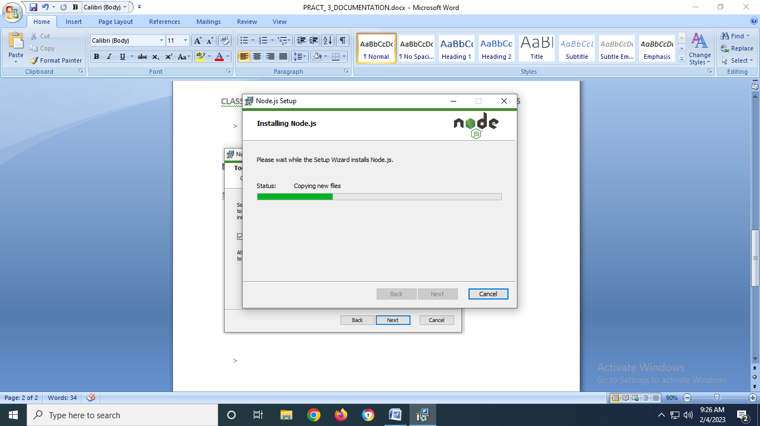

* Setting up environment variable: -

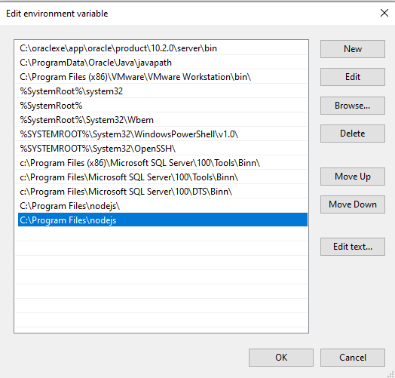

* Printing Hello World :-

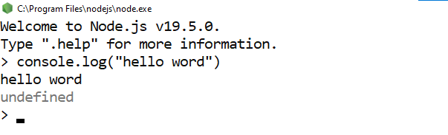

* Creating own module and accessing it :-
* **CODE (mymodule.js) :-**

exports.mydate=function(){

return Date();

}

exports.mymessage=function(){

return"Welcome to message form module";

}

* **CODE (mymoduleim.js) : -**

var http=require('http');

var md=require('./mymodule');

http.createServer(function(req,res){

res.writeHead(200,{'Content-Type':'text/html'});

res.write("<b>Cureent Date and time is: "+md.mydate());

res.write("<br>Message :"+md.mymessage());

}).listen(8080);

* **Run the Server : -**

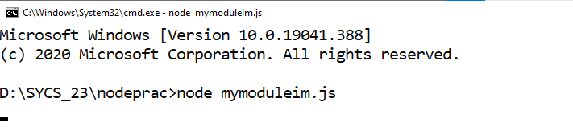

* **OUTPUT :-**

